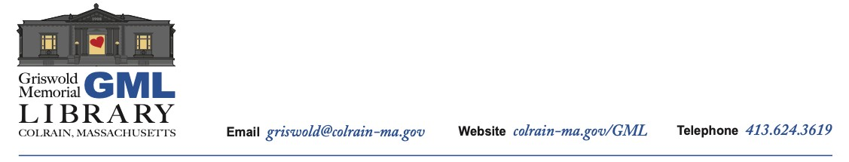

**GML Board of Trustees, Fix-it Day Committee Zoom Meeting Agenda**

**Monday, August 18, 2022 at 8:30am**

Topic: GML Fix-it Day Committee planning meeting

Time: Aug 18, 2022 08:30 AM Eastern Time

Join Zoom Meeting

https://us06web.zoom.us/j/83960315473?pwd=bitwTHBLdE5xajV3ZFNsZkhGQk1LQT09

Meeting ID: 839 6031 5473

Passcode: 377064

1. Approval of meeting agenda

1. Updates on

a. Fixers and other volunteers  
b. Workshops: upcycle, Scribble Stones, joinery, Historical Society, others?   
c. Tables: kid’s table, free table, Library table w/fix-it books  
d. Music, food  
e. Logistics (tents, electricity, lighting)  
f. Promotion (posters, press release, signage)

*Other Items Not Anticipated by the Chair 48 Hours Prior to Meeting May be Added*