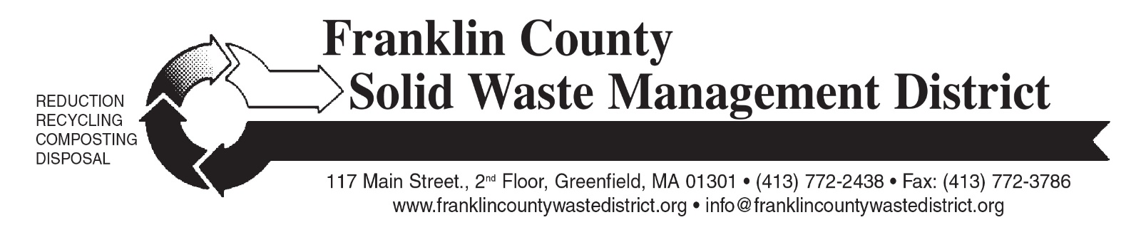

PRESS RELEASE: for Immediate Release

Contact: Amy Donovan, Program Director: amy@franklincountywastedistrict.org

Fall Bulky Waste Day Cancelled

Franklin County Solid Waste District's Fall "Clean Sweep" Bulky Waste Recycling Day, previously scheduled for October 17, has been cancelled.

Residents can take most items that are collected at Clean Sweep to Greenfield Transfer Station, which is open to non-residents for a $5 fee per load, plus specific disposal fees per item. For hours and pricing, see: https://tinyurl.com/GreenfieldTS.
Residents are encouraged to recycle computer equipment and televisions at their own town’s transfer station, if an e-waste collection program is available there, or at Greenfield Transfer Station. Residents can go to the District’s website (www.franklincountywastedistrict.org) to find town-specific information on the 17 transfer stations in the District, which remain open for proper disposal of many items.
Staples stores accept computer equipment (no TVs) free of charge: call your local store for details. Various charities and non-profits accept donations of working electronics, including local Salvation Army and Goodwill stores. Always call ahead to ask if they can accept your item.
Additional questions about proper disposal of trash, bulky waste, recyclables, hazardous wastes, yard waste, or food waste can be directed to the Franklin County Solid Waste District at 413-772-2438 (leave a message with your phone number and town of residence), or email info@franklincountywastedistrict.org. MA Relay for the hearing impaired: 711 or 1-800-439-2370 (TTY/TDD). The District is an equal opportunity provider.

